**Technical Document**

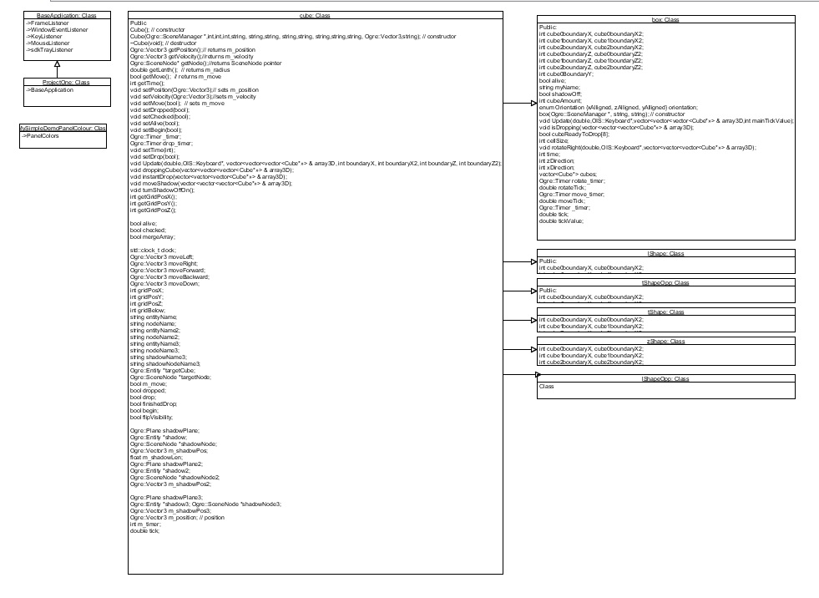**UML Diagram**

**As this uml diagram is hard to see we have added the uml file to the folder for easier viewing.**

**Class Documentation**

**Detailed references to tools or resources used**

* Ogre
* Paint
* Jira
* GitHub

**Detailed references to 3rd party code used**

Ogre Code provided in new project (base Application etc.)

Declarations of Originality

DECLARATION

I declare that the work I am submitting for assessing by the Institute examiner(s) is entirely my own work, save for any portion(s) thereof where the author or source has been duly referenced and attributed.

I further state that I have read, and am familiar with, the Institute Examination and Assessment Regulations and that I am not, so far as I am aware, in breach of any of these regulations.

Student Name:……………………………….Student ID Number:………………

Course of Study:…………………………………………………………………..

SIGNED:_________________________________DATE:_________________

DECLARATION

I declare that the work I am submitting for assessing by the Institute examiner(s) is entirely my own work, save for any portion(s) thereof where the author or source has been duly referenced and attributed.

I further state that I have read, and am familiar with, the Institute Examination and Assessment Regulations and that I am not, so far as I am aware, in breach of any of these regulations.

Student Name:……………………………….Student ID Number:………………

Course of Study:…………………………………………………………………..

SIGNED:_________________________________DATE:_________________